**Reversi**

***Table of Contents***

*Project overview ……………………………………………………………….3*

*Project description ……………………………………………………………..4*

*Login interface ………………………………………………………….4*

*Signup interface ……………………………………………………….5*

*Main Menu interface ………………………………………………..6*

*Start Game ……………………………………………………..7*

*High Score ……………………………………………………….8*

*Top Ten ……………………………………………………………9*

*Help ………………………………………………………………..10*

*Exit …………………………………………………………………10*

***Project Overview:***

*The project is a client server Reversi game. Users can play the game on Android platform.*

*Reversi is a strategy board game for two players, played on an 8×8 un-checkered board. There are 64 identical game pieces called disks, which are light on one side and dark on the other. Players take turns placing discs on the board with their assigned color facing up.*

***Project Description:***

*This game consists of Three Basic interfaces:*

***Login Interface:***

*In this page, you can login to the game with your username and password.*

*If you don’t have an account, you can create new account by pressing signup button.*

***The design of this interface:***

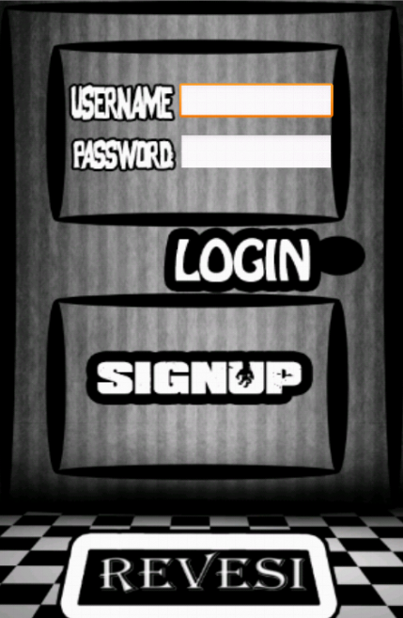

***Signup Interface:***

*In this page, you’ll fill the form in it with your information and after clicking signup button, you’ll be inserted into database and you’ll have a new account.*

***The design of this interface:***

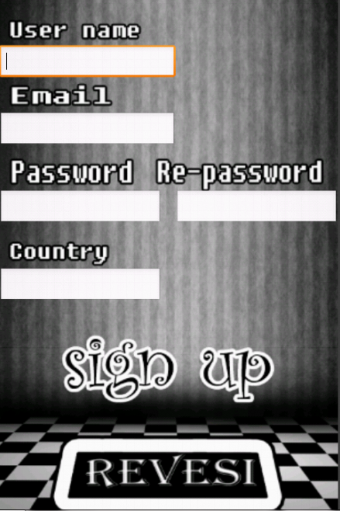

***Main Menu Interface:***



*This page consists of many buttons:*

1. *Start Game: Here you start to play the game.*

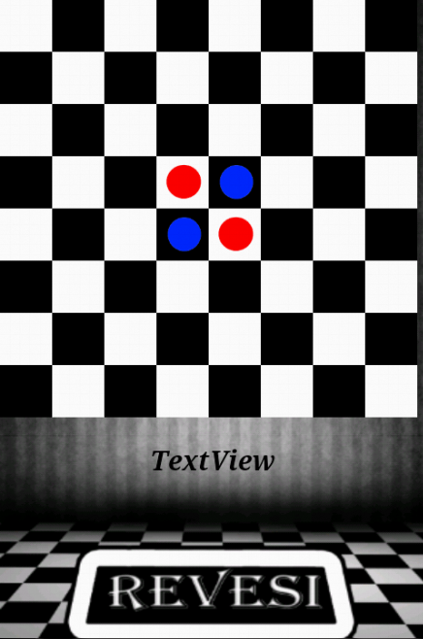

1. *High Score: You can see your high score.*

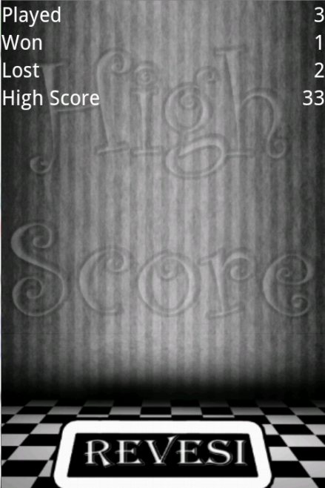

1. *Top Ten: You can see the top ten of this game.*

**

1. *Help: It displays a simple description of the game.*

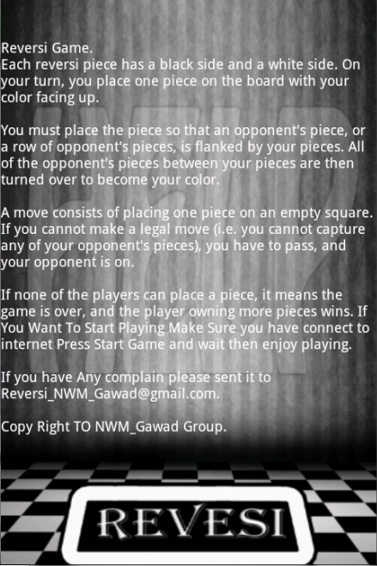

1. *Exit: You can logout and go back to Login page.*